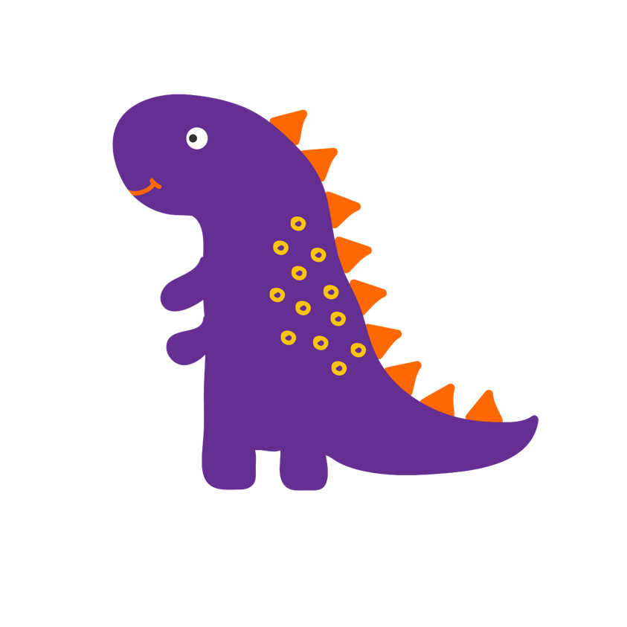

**The other dinosaurs in my class seem to be growing quicker than me, I feel left out, it’s making me feel sad.**

**I have started to notice I’m smelling a bit after playing sport. I feel a bit embarrassed.**

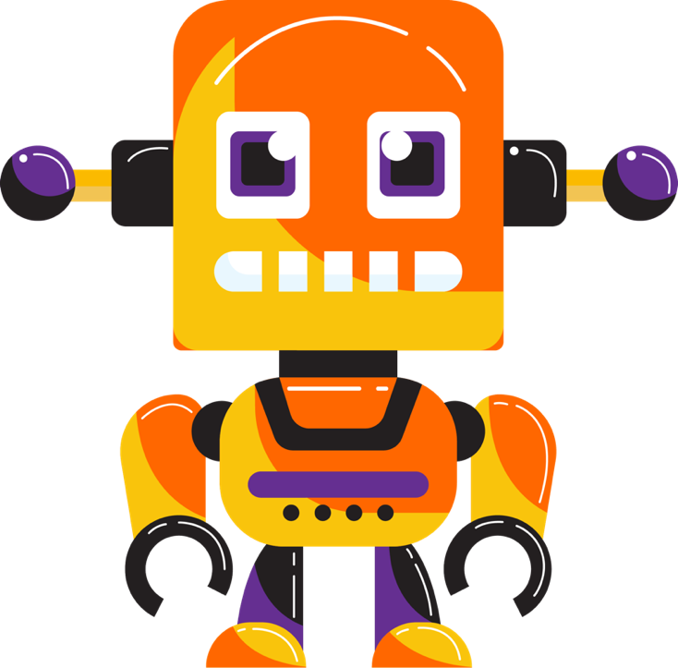

**I’ve been feeling a bit angry at my Robot parent for no reason. He asked me to tidy my room while I was playing a game and I stormed off and slammed the door!**