When an adult couple are in a relationship they may want to have sex. This is when they touch each other in a sexual way and it feels pleasurable.

Sometimes when people are having sex the penis gets stiff and the vagina gets slippery.

Now the vagina can take the penis being

inserted into it. It should feel nice.

After a while a liquid (semen) is pushed out of the end of the penis. It has millions of tiny sperm in it.

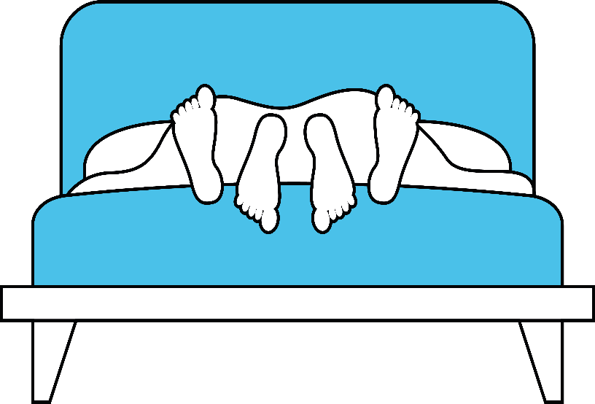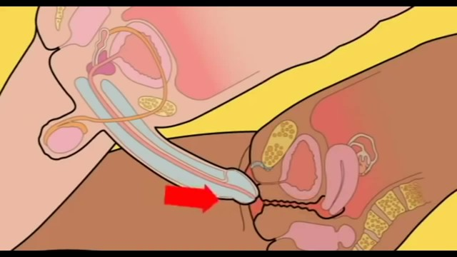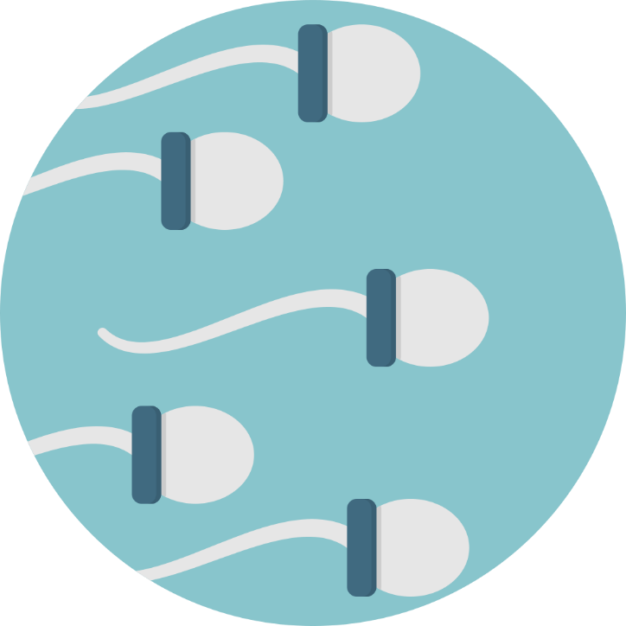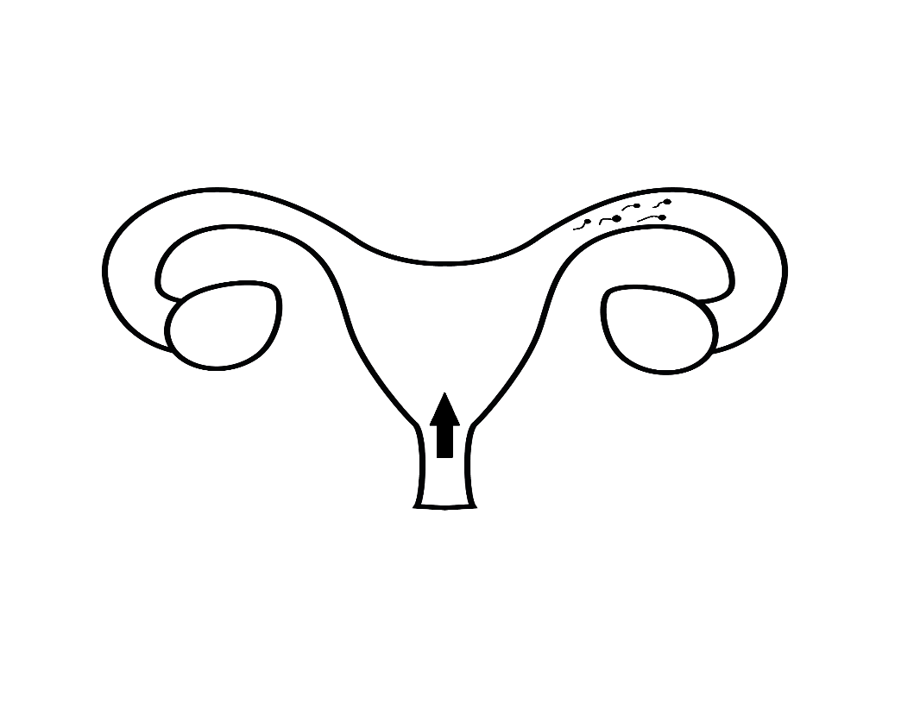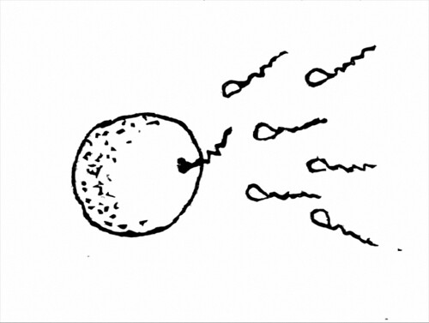

If there is an egg in the fallopian tube, one sperm will join up with it. The egg is now fertilised.

This is the start of pregnancy. The baby will grow in the womb for nine months until it is born.

The sperm swim up the vagina, to the womb and into the fallopian tubes.

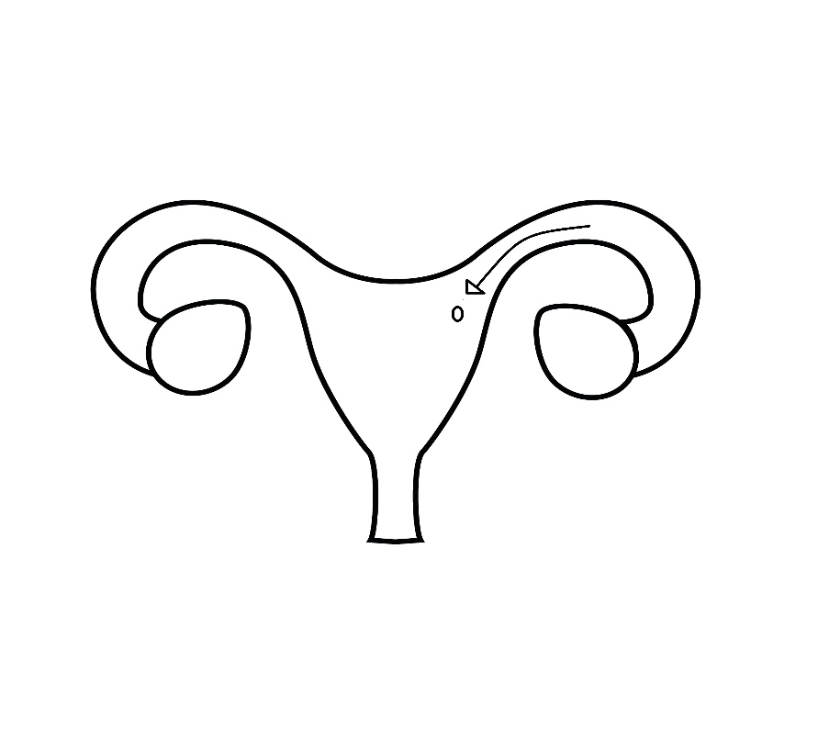

The fertilised egg travels towards the womb. It implants in the womb and starts to grow.

