CYCLE & PERIOD TRACKER
Write down the months (starting with this one) in the first column.
Then mark when you get your period using the days of the month. You could have different colours/patterns for how heavy it is.
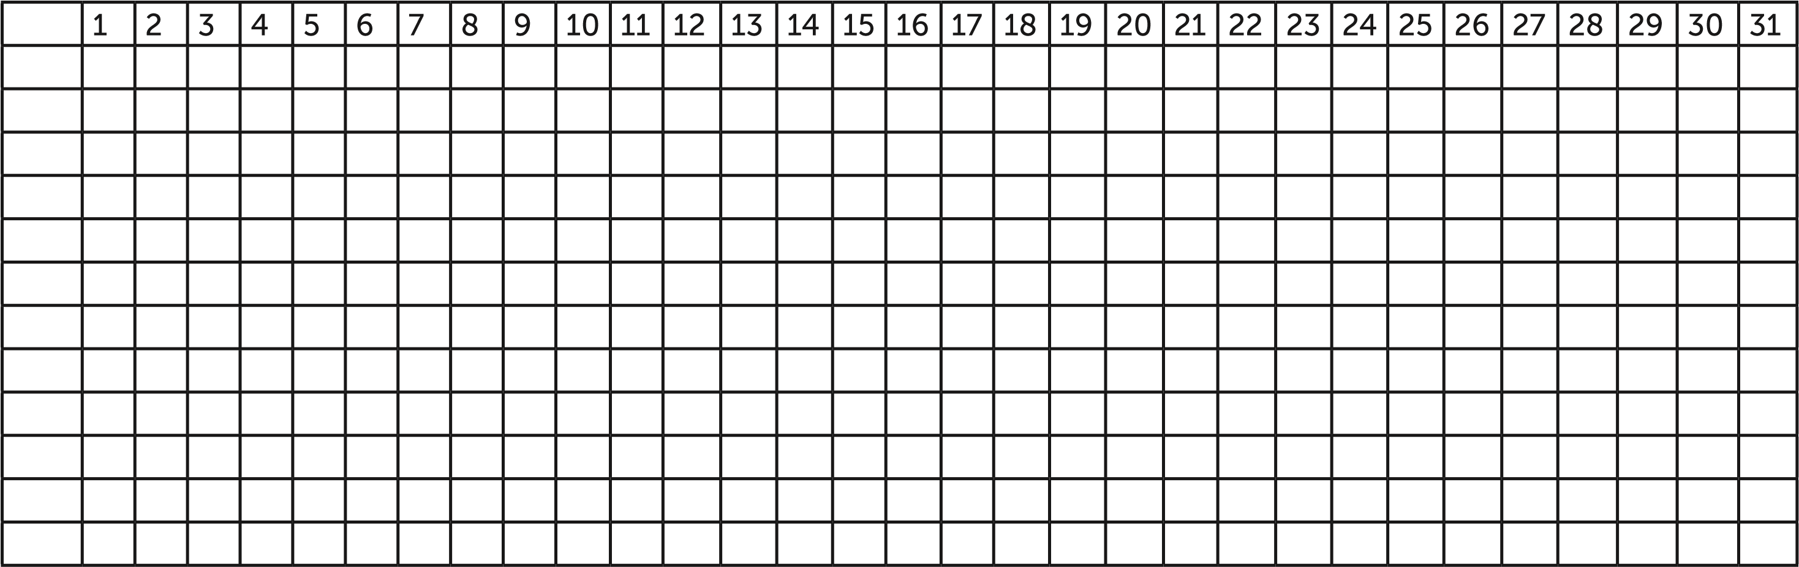

spotting light heavy regular none

MOOD & SIGNS TRACKER
Write down the months (starting with this one) in the first column. Using different colours or patterns mark off how you’re feeling during your cycle e.g., tired or spotty or energetic.
Make a key using the boxes to keep track.

