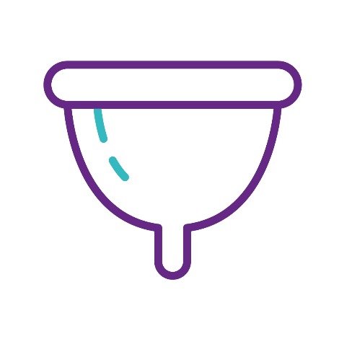
Menstrual Cup
A soft silicone cup that is folded and inserted into the vagina, with clean hands, and opens up inside. It catches the blood, rather than absorbs it. It can be left in for up to 8 hours, then you remove it and empty the blood. You can wipe or rinse it and reinsert. After each period you’ll need to clean it thoroughly with boiling water and keep it stored in a clean, dry place.
+ You can’t feel it when it’s in correctly
+ Better for the environment & last for up to 10 years
+ It’s good for doing exercise in
- It may take a little bit of time to get used to inserting and removing it, including the period blood
-Expensive to buy compared to other products, though can save money overall

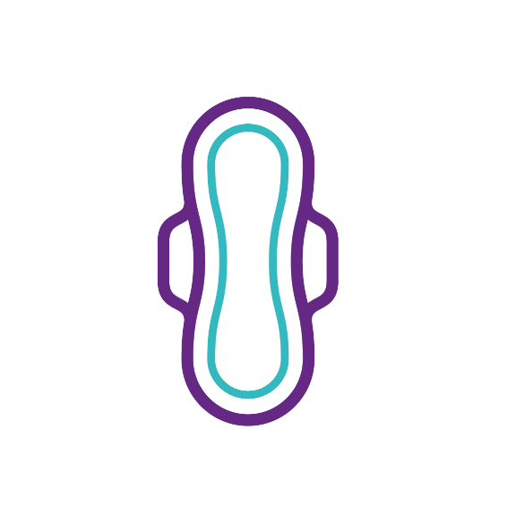
Pads
Made of absorbent material to absorb blood. Have a sticky back - and sometimes wings – to keep them in place in your underwear.You can get them in different absorbencies and with wings or without, depending on how heavy your period is.
+Easy to use & easily available
+ +You can wear them safely overnight
+You can throw them away after use into a bin
- You can feel the pad and sometimes the wetness of your period blood when wearing them
- Not good for the environment
- Can’t do certain sports when wearing them
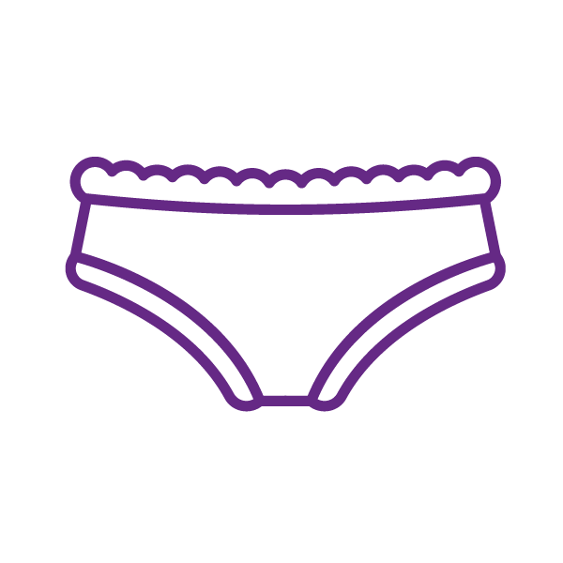
Applicator Tampons
Are small tubes of material with applicators, made of cardboard or plastic and absorb the menstrual blood. Shouldn’t be kept in for more than 8 hours. Don’t worry, they can’t get stuck or lost! They have a string attached to pull them out with. You should only use one at a time, only use on your period and use a size suitable for your flow (e.g. don’t use a super absorbency on your lighter days). They should be thrown in a bin, not flushed down the toilet.
+ Easily available
+ You can’t feel them when they are properly inserted
+ Able to do sports in them and can go swimming wearing them
- Not good for the environment as some applicators are made from single use plastics
- There is an association between Toxic Shock Syndrome (TSS) and the use of internal period protection, although there is no medical evidence to show if length of use contributes to TSS.
- Can take time to learn how to use
Non-applicator Tampons
Are small tubes of soft cotton, inserted into the vagina with your finger and absorb the menstrual blood. Shouldn’t be kept in for more than 8 hours. Don’t worry, they can’t get stuck or lost! They have a string attached to pull them out with. You should only use one at a time, only use on your period and use a size suitable for your flow (e.g. don’t use a super size on your lighter days). They should be thrown in a bin, not flushed down the toilet.
+ Easily available
+ Throw in the bin after use
+ You can’t feel them when they are properly inserted
+ Able to do sports in them and can go swimming wearing them
+ They have less plastic than plastic applicator tampons and are therefore better for the environment
- There is an association between Toxic Shock Syndrome (TSS) and the use of internal period protection, although there is no medical evidence to show if length of use contributes to TSS.
- Can take time to learn how to use
Period Pants
Period pants are made with built in absorbency technology and look like ordinary pants/ knickers. Depending on how heavy your period is, you can use them as an alternative to other products or use them with other products. After use, you should rinse them in cold water until the water runs clear, put them in the washing machine on a cold cycle not using any fabric conditioner and hang them out to dry. Then you can reuse them.
+ Can safely wear them overnight
+ Easy to use
+ One pair lasts for 6 months – 2 years
+ Better for the environment
- Need to wash after use
-Can’t do some sport while using them
- Might need to take an extra pair with you if you have a heavy flow
plus a wet bag to keep them in
Reusable Pads
Made from cotton and/or bamboo and are put into your underwear to absorb the period blood. After use, rinse the pad under cold water and put it into the washing machine. It’s best not to use fabric conditioner as it can affect the absorbency. The breathable material means used pads will not smell. You may change them one to six times a day depending on how heavy your period is.
+ Easy to use
+ Safe to wear overnight
+ Can get different patterns and styles
+ Better for the environment
+ Can wash pads when it’s convenient for you
- Can feel the wetness of the blood on the pad when you need to change
- Need to wash after use
-Can’t do some sports while wearing them
- May need to carry 2-3 with you and a wet bag depending on how heavy your period is

