Advise a Friend Quotes

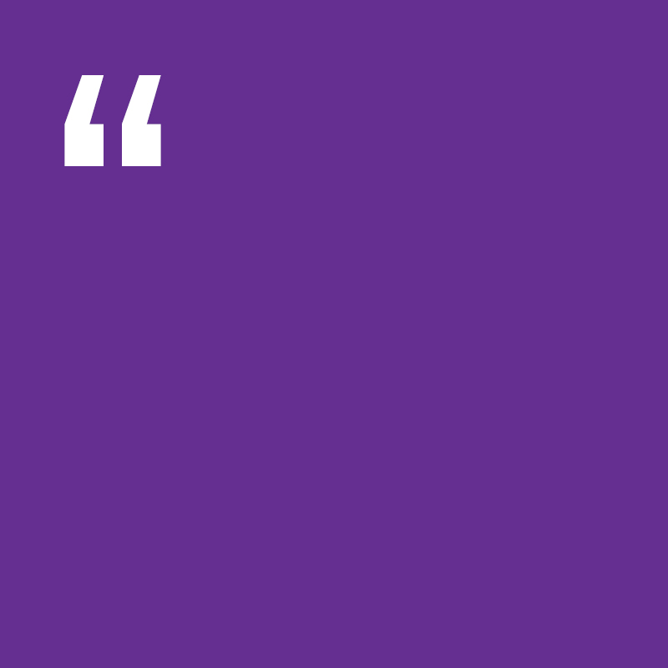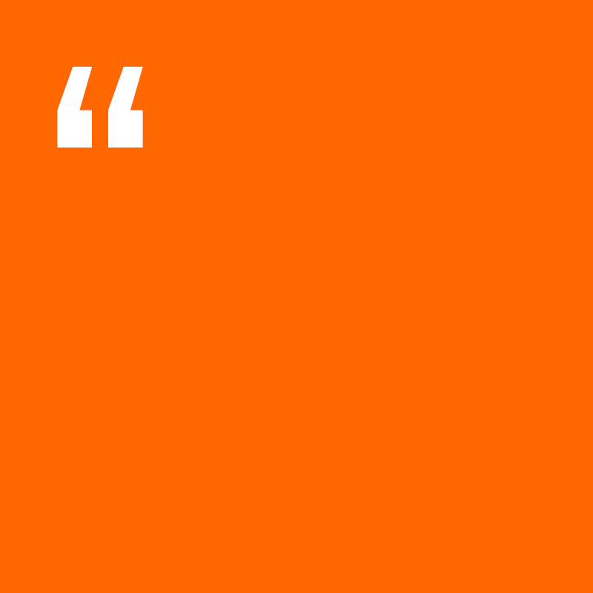

**I’ve not started puberty yet, all of my friends have, it’s making me worried (Sam, 12)**

**‘I’m finding it really hard to manage my moods, one minute I’m really happy the next minute I feel sad’ (Jack, 14)**

**‘I just started my period, I don’t have any period products at home, and I don’t think dad can afford them’**

**(Alex, 13)**